**VPC Endpoint Services**

* VPC Endpoint is an entry point in your vpc that enables you to privately connect to a Service. There are three different types of VPC Endpoints
  + Gateway Endpoint:
    - This enables us to connect to s3 and DynamoDb
  + Interface Endpoint:
    - This endpoint creates a network interface in your cidr range to connect to AWS Service
  + Gateway Load Balancer endpoint
* pricing Link: <https://aws.amazon.com/privatelink/pricing/>

**Lab setup**

* Create a vpc with one public subnet and two private subnets
* Create an ec2 instance in the public subnet (t2.micro) with public ip with ubuntu 20
* Login into to the ec2 instance and execute the following commands to install lamp server on ec2

sudo apt update

sudo apt install apache2 -y

sudo apt install php libapache2-mod-php php-mysql -y

echo '<?php phpinfo() ?>;' | sudo tee /var/www/html/info.php

sudo systemctl restart apache2

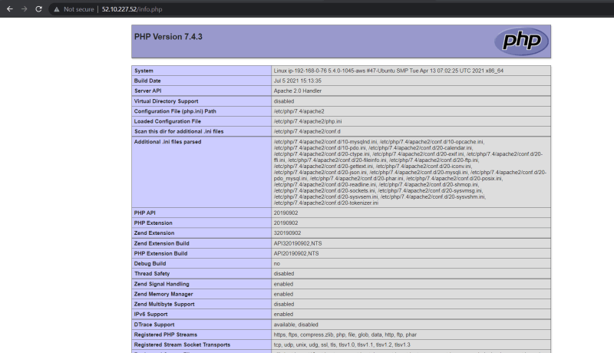

* Now create an image (AMI) from this ec2 instance 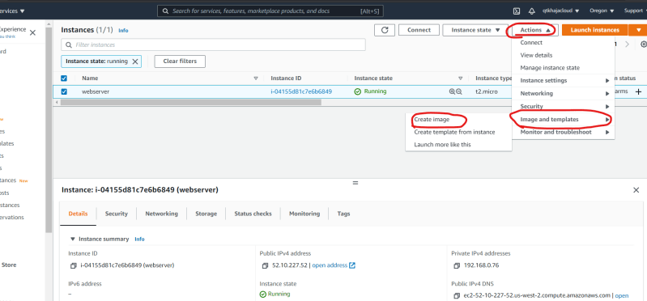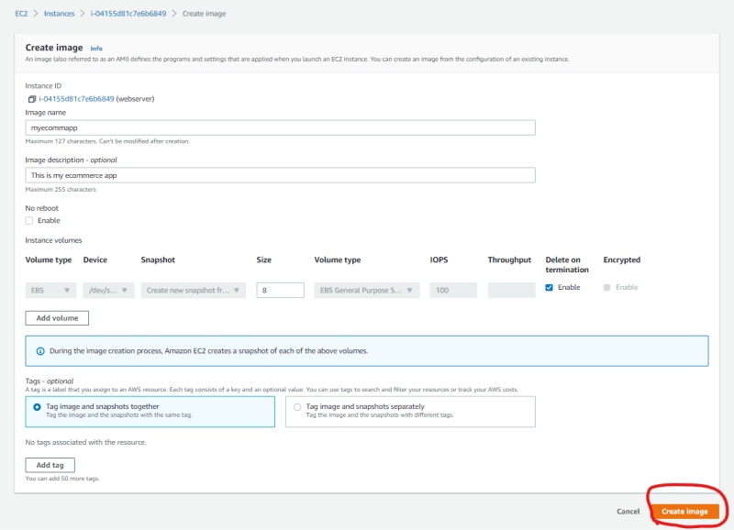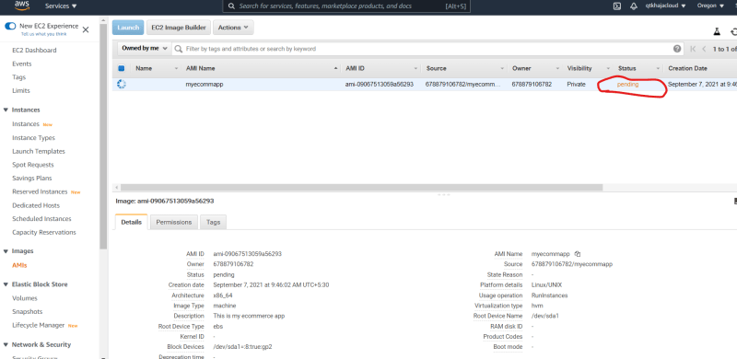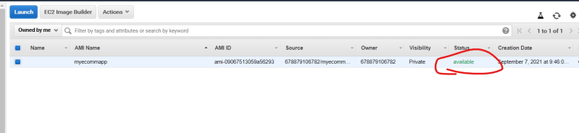
* Now delete the ec2 instance which was created above